MarketPulse
Minor Project-II
(ENSI252)
Submitted in partial fulfilment of the requirement of the degree of
BACHELOR OF TECHNOLOGY
to
K.R Mangalam University
by
Priyanshu (2301420060)
Ansh Vashist (2301420019)
Yash Chauhan (2301420059)

Under the supervision of
Ms. Neetu Jatin Dagar
Co-Founder
Digital Idea Force


Department of Computer Science and Engineering
School of Engineering and Technology
K.R Mangalam University, Gurugram- 122001, India
April 2025

CERTIFICATE

This is to certify that the Project Synopsis entitled, “MarketPulse” submitted by “Priyanshu(2301420060), Ansh Vashist(2301420019) and YAsh Chauhan(2301420059)” to K.R Mangalam University, Gurugram, India, is a record of bonafide project work carried out by them under my supervision and guidance and is worthy of consideration for the partial fulfilment of the degree of Bachelor of Technology in Computer Science and Engineering of the University.

Type of Project
Industry/Research/University Problem

Ms. Neetu

Signature of Project Coordinator

Date: 30 April 2025

INDEX

Abstract
Introduction
Motivation

Literature Review/Comparative work evaluation

Gap Analysis

Problem Statement

Objectives

Tools/platform Used

Methodology

Implementation

Results And Discussion

Conclusion & Future Work

References

- ABSTRACT
With the rise of digital transformation, businesses require an online presence to effectively engage with their customers. The Digital Idea Force Website aims to provide a user-friendly, visually appealing, and responsive platform for the marketing agency. It will offer detailed information about services, showcase client portfolios, and provide an interactive interface for customer engagement. The website will be developed using modern web technologies to ensure seamless navigation, security, and optimized performance.
Additionally, the project will integrate essential features such as dynamic contact forms, service listings, and SEO optimization to enhance online visibility. The website will serve as a bridge between Digital Idea Force and potential clients, ensuring a streamlined and efficient marketing experience.
Keywords: Website Development, UI/UX Design, Web Technologies, SEO Optimization, Digital Presence, User Experience, Performance Optimization

2. Introduction
1. Background of the Project
In today’s hyper-connected world, where the digital landscape is evolving at breakneck speed, a compelling and professional online presence has become an absolute necessity for businesses across all sectors. With more than half of the global population actively engaged online, companies that fail to establish a robust digital identity risk losing visibility, credibility, and ultimately, profitability. Digital Idea Force, a cutting-edge digital marketing agency, recognizes this growing need and aims to bridge the gap between traditional marketing practices and modern, tech-enabled branding strategies.
Over the years, businesses have transitioned from brick-and-mortar models to online-first platforms. However, in this saturated digital ecosystem, merely existing online is no longer enough. Brands need strategic positioning, creative storytelling, data-driven campaigns, and responsive user experiences to truly thrive. This is where Digital Idea Force enters the picture—with its specialized expertise in search engine optimization (SEO), social media marketing, pay-per-click (PPC) advertising, and conversion-focused design.
The proposed website for Digital Idea Force will serve as a centralized hub to showcase its dynamic range of services, industry success stories, performance-driven case studies, and thought leadership. The site will not just be a visual portfolio, but a powerful communication tool tailored to engage potential clients and retain existing ones. The goal is to combine creativity with functionality—crafting a seamless, engaging, and intuitive experience for users across all devices, from desktops and laptops to smartphones and tablets.
In addition to service overviews, the website will also highlight the agency’s unique methodologies, client testimonials, and strategic insights into industry trends. This immersive digital experience will empower clients to understand how Digital Idea Force transforms business objectives into measurable digital success through tailored strategies and real-time analytics.
Moreover, in an age where user experience defines brand loyalty, the website will incorporate interactive elements, modern design aesthetics, fast loading speeds, and SEO optimization. All content will be crafted to inform, inspire, and drive action—ensuring that visitors not only stay longer but also convert faster.
Through this platform, Digital Idea Force seeks not only to elevate its brand image but also to provide value-driven content and innovative marketing solutions to entrepreneurs, small businesses, and enterprises seeking to navigate the complexities of digital growth. By harnessing the power of technology and creativity, the website will reflect the agency’s mission: to deliver meaningful, results-oriented digital marketing that empowers brands to lead in their niche.

3. MOTIVATION
The motivation behind this project stems from the need to develop a professional and functional website that effectively represents Digital Idea Force and its services. Several key factors drive this project:

- Need for a Strong Online Presence: In today’s digital era, a website serves as the face of a company. A well-developed website can enhance credibility, attract new clients, and establish Digital Idea Force as a leading marketing agency.
- Enhancing User Experience: Many marketing agencies have poorly designed websites that make navigation difficult for users. This project aims to create a user-friendly, interactive, and visually appealing website to ensure a seamless browsing experience.
- SEO Optimization for Visibility: A well-optimized website is essential for appearing in search engine results. By implementing SEO best practices, this project ensures that Digital Idea Force achieves higher visibility and reaches a broader audience.
- Integration of Digital Tools: With technological advancements, clients expect websites to offer interactive features such as real-time contact forms, service descriptions, and project showcases. This website will incorporate modern web technologies to meet these expectations.
- Competitive Edge in the Industry: In the fast-growing marketing industry, having a well-structured website differentiates Digital Idea Force from its competitors, attracting more business opportunities and potential partnerships.

By addressing these critical factors, this project will contribute to enhancing Digital Idea Force’s brand identity, customer engagement, and overall business growth.

4. LITERATURE REVIEW
Review of Existing Literature
Numerous studies and industry reports have explored the evolving role of digital marketing platforms in shaping business growth and customer engagement. These insights reveal that the strategic integration of web technologies, automation, and analytics can drastically transform how businesses reach, convert, and retain customers in the competitive digital ecosystem.
SEO Optimization and Visibility
Search Engine Optimization (SEO) remains one of the most impactful strategies for improving website visibility. Research indicates that SEO-optimized websites rank significantly higher in search engine results, leading to increased web traffic and greater lead conversion. This is especially crucial for businesses aiming to establish domain authority and organic reach over time. A well-structured SEO strategy—encompassing keyword targeting, metadata optimization, and backlink building—ensures sustained discoverability and user engagement.
User Interface Design and Responsiveness
Several usability studies highlight the role of intuitive design in enhancing user experience. Websites with responsive design—adapted for desktops, tablets, and smartphones—report higher retention rates and lower bounce rates. A clean, interactive, and mobile-friendly interface fosters trust and encourages user interaction. Such platforms also contribute to longer session durations and improved navigation efficiency, both of which are essential for customer satisfaction and brand credibility.
Marketing Automation and Campaign Management
The integration of marketing automation tools, such as CRM systems, email marketing workflows, and AI-driven chatbots, has shown to streamline client interactions and improve overall campaign effectiveness. These tools enable businesses to personalize outreach, nurture leads efficiently, and analyze customer behavior in real time. The result is improved ROI on marketing efforts and higher customer lifetime value.
Case Studies on Digital Engagement Platforms
Empirical evidence from case studies supports the claim that interactive and analytics-powered websites lead to higher conversion rates and greater customer loyalty. Businesses that leverage features such as dynamic content, behavior tracking, personalized CTAs, and real-time feedback forms report stronger user engagement and a marked increase in qualified leads. These platforms empower companies to translate insights into actionable strategies, ensuring continued growth in a data-centric environment.

Building Upon These Insights
This project builds upon the foundational research by embedding SEO optimization, responsive design principles, and automation technologies into a single, cohesive digital platform. The website for Digital Idea Force will not only reflect the agency's core competencies but also utilize real-time analytics and marketing tools to measure success and improve ongoing strategies. Just as advanced CCTV systems have evolved from passive recording devices into proactive, AI-driven surveillance tools, modern marketing websites are evolving into intelligent hubs for branding, client engagement, and growth.
By synthesizing current best practices in web development and digital marketing, this platform aspires to serve as a benchmark for interactive agency websites—prioritizing performance, usability, and measurable outcomes.

5. GAP ANALYSIS
A well-designed and high-performing website is crucial for any marketing agency, yet many agencies fail to meet essential digital standards. Common challenges include:

- Outdated website designs
- Lack of SEO optimization leading to poor search rankings
- Non-responsive layouts affecting user experience on mobile devices
- Slow page load speeds causing high bounce rates
- Limited interactive features for customer engagement

This project aims to bridge these gaps by building a highly responsive, SEO-optimized, and user-friendly website with an emphasis on modern web standards and industry best practices.

6. PROBLEM STATEMENT
- Traditional marketing agencies often lack an optimized online presence, leading to numerous challenges such as low engagement, poor visibility, and ineffective communication with potential clients. A poorly designed website can lead to high bounce rates, making it difficult for marketing agencies to retain visitor interest and convert leads into customers.

- Many existing agency websites suffer from out-dated Designs slow performance, and non-responsive layouts, which significantly impact usability and overall business growth. Furthermore, a lack of SEO optimization reduces online discoverability, limiting an agency's reach to potential clients who rely on search engines for marketing solutions.

- This project aims to address these challenges by developing a modern, visually appealing, and highly functional website that ensures better user experience, higher search engine rankings, and enhanced digital presence. By implementing an intuitive interface, Digital Idea Force can efficiently display its services, engage potential clients, and improve business credibility.

- Additionally, integrating advanced real-time contact forms, service listings, client testimonials, and case studies will further enhance engagement and communication. The project will also focus on performance optimization to ensure fast load times and seamless navigation, reducing frustration and increasing retention rates.

- By leveraging cutting-edge web technologies and industry best practices, this project will provide a scalable and future-proof website for Digital Idea Force, ensuring long-term growth and a competitive edge in the marketing industry.

7. OBJECTIVES

- Developing a Functional and User-Friendly Website: The primary goal of this project is to create a fully functional and user-friendly website that effectively represents Digital Idea Force. The website will feature a clean and modern design, ensuring ease of navigation, accessibility, and responsiveness across all devices. A well-structured UI/UX will enhance user engagement and encourage potential clients to explore the agency’s offerings.

- Implementing SEO Strategies for Better Visibility: To improve the discoverability of Digital Idea Force, the project will implement search engine optimization (SEO) strategies. This includes optimizing content with relevant keywords, enhancing website structure for search engine indexing, and integrating meta descriptions and backlinks. These efforts will ensure that the website ranks higher in search engine results, attracting more organic traffic and potential clients.

- Bringing Organic Traffic and Managing It Effectively: A key objective of the website is to drive organic traffic and retain visitors through valuable content and interactive features. The project will focus on content marketing strategies such as blogs, case studies, and client testimonials to engage users. Additionally, tools like Google Analytics and real-time tracking will be incorporated to monitor visitor behavior, helping in continuous optimization and efficient traffic management.

By achieving these objectives, Digital Idea Force will establish a strong digital presence, improve client outreach, and create an effective platform to showcase its expertise in the marketing industry.

8. Tools, and Platform Utilized
PLATFORM USED
To develop a dynamic, responsive, and feature-rich website for Digital Idea Force, a combination of modern web technologies and server-side tools has been utilized. These tools were selected to ensure seamless performance, easy maintenance, cross-platform compatibility, and scalability to support future business growth. This section outlines the technologies used, their specific roles in the development lifecycle, and the reasons for their selection.

FRONT-END TECHNOLOGIES

1. HTML (HyperText Markup Language)
HTML is the standard markup language used to structure content on the web. It forms the foundation of all web pages by organizing text, images, buttons, and other elements in a coherent layout.
Reasons for Use:
- Acts as the backbone of the website.
- Ensures structured and semantically correct content.
- Compatible with all browsers and devices.

2. CSS (Cascading Style Sheets)
CSS is used to style and visually design the HTML content, including layouts, colors, fonts, and animations.
Reasons for Use:
- Enables responsive and visually appealing designs.
- Separates presentation from content for better maintainability.
- Allows for reusability of styles across the website.

3. JavaScript
JavaScript adds interactivity to the website, enabling dynamic content updates, form validations, interactive sliders, and real-time user feedback.
Reasons for Use:
- Enhances user experience with interactive elements.
- Enables DOM manipulation and event handling.
- Widely supported by all modern browsers.

BACK-END TECHNOLOGIES

4. PHP (Hypertext Preprocessor)
PHP is a widely-used open-source server-side scripting language designed for web development. It handles data processing, server requests, form submissions, and connection with databases.
Reasons for Use:
- Excellent integration with HTML and MySQL.
- Cost-effective (open-source and widely supported).
- Suitable for developing scalable and secure web applications.

5. MySQL (Structured Query Language)
MySQL is a relational database management system used to store, manage, and retrieve website data such as client details, inquiries, service records, and more.
Reasons for Use:
- Fast, reliable, and secure for handling structured data.
- Highly compatible with PHP.
- Open-source with a strong support community.

9. METHODOLOGY
The development of the Digital Idea Force website follows a structured methodology to ensure efficiency, usability, and high performance. The key steps involved in the process include:

- Service Browsing & Selection: Visitors to the website can explore a range of marketing services offered by Digital Idea Force. Categorized service listings with detailed descriptions, case studies, and pricing information will help users make informed decisions. The inclusion of search and filtering options ensures that clients can quickly find the services they need.

- Inquiry Processing & Communication: Once a client selects a service, they can submit inquiries or schedule consultations. The backend system will send real-time notifications to the Digital Idea Force team, ensuring prompt responses. Automated email confirmations and follow-ups will improve customer engagement and service efficiency.

- Feedback & Continuous Improvement: After project completion, users will be encouraged to provide feedback on their experience. This feedback will be analyzed to enhance service offerings and website features, ensuring that Digital Idea Force continues to evolve in response to client needs.

By following this structured methodology, the Digital Idea Force website will streamline service delivery, improve customer satisfaction, and position the company as a leading player in the digital marketing industry.

10. Implementation

1. Detailed Explanation of How the Project Was Implemented
The implementation of the Digital Idea Force website followed a structured and modular approach to ensure clarity, scalability, and maintainability. The development process was divided into key phases, each with specific objectives and deliverables, from design planning to front-end creation, back-end development, and final testing. Below is a step-by-step breakdown of the implementation strategy:

1. Requirement Analysis and Planning
The first step involved understanding the core goals of the website:
- Showcase the agency’s digital marketing services and expertise.
- Build an interactive and user-friendly platform.
- Enable clients to contact or request services easily.
- Ensure mobile and desktop responsiveness.
A detailed plan was created outlining the necessary features, page layouts, navigation flow, and technologies to be used.

2. UI/UX Design and Wireframing
Low-fidelity wireframes were created to visualize the layout of key pages such as:
- Home
- About Us
- Services
- Case Studies
- Contact
Focus was placed on maintaining a clean, modern interface to reflect the professionalism of a digital marketing agency. A responsive design layout was ensured using CSS Flexbox and Grid.

3. Front-End Development
Front-end development was implemented using the following technologies:
- HTML: Used to create the structural elements of the web pages, including headers, service sections, image containers, forms, and footers.
- CSS: Applied for styling, theming, and layout management. Media queries were used for responsive design across screen sizes.
- JavaScript: Used to add interactivity such as:
  - Smooth scrolling
  - Toggle menus for mobile views
  - Dynamic loading effects
  - Form validation for user input on the contact page
This phase also involved testing UI behavior across major browsers (Chrome, Firefox, Safari) and devices.

4. Back-End Development
Server-side functionality was developed using PHP, while MySQL handled database operations.
- PHP:
  - Managed form submissions (e.g., contact forms).
  - Dynamically rendered content based on data stored in the database.
  - Handled user feedback messages after actions like form submission.
- MySQL:
  - Created structured tables for storing client inquiries, contact data, and service request records.
  - Implemented CRUD operations (Create, Read, Update, Delete) for data management.
A local server environment (XAMPP) was used during development to host PHP and MySQL components.

5. Contact Form Integration
A functional contact form was implemented using:
- HTML/CSS for layout and styling
- JavaScript for client-side validation
- PHP for backend processing
- MySQL for storing user queries and messages
The form included fields such as name, email, subject, and message. Data submitted was stored securely and sanitized to prevent SQL injection.

6. Testing and Debugging
Comprehensive testing was conducted at each development phase to ensure:
- Cross-browser compatibility
- Mobile responsiveness
- Functional validation and error handling
- Database connectivity
- Speed and performance optimization
Issues such as broken links, layout shifts, and incorrect form validations were identified and resolved.

7. Deployment
Once finalized, the website was deployed on a live hosting environment. A domain was configured, and all files were uploaded to the server using FileZilla. The live database was imported via phpMyAdmin, and the project went through a final round of testing in production.

8. Post-Launch Enhancements
After deployment, additional tasks included:
- SEO meta tag implementation
- Google Analytics integration for traffic tracking
- Security hardening (basic CAPTCHA, input sanitization)

This structured development ensured that the Digital Idea Force website is not only visually appealing and feature-rich but also fast, secure, and scalable.

2. Description of algorithms, code snippets, or design diagrams.

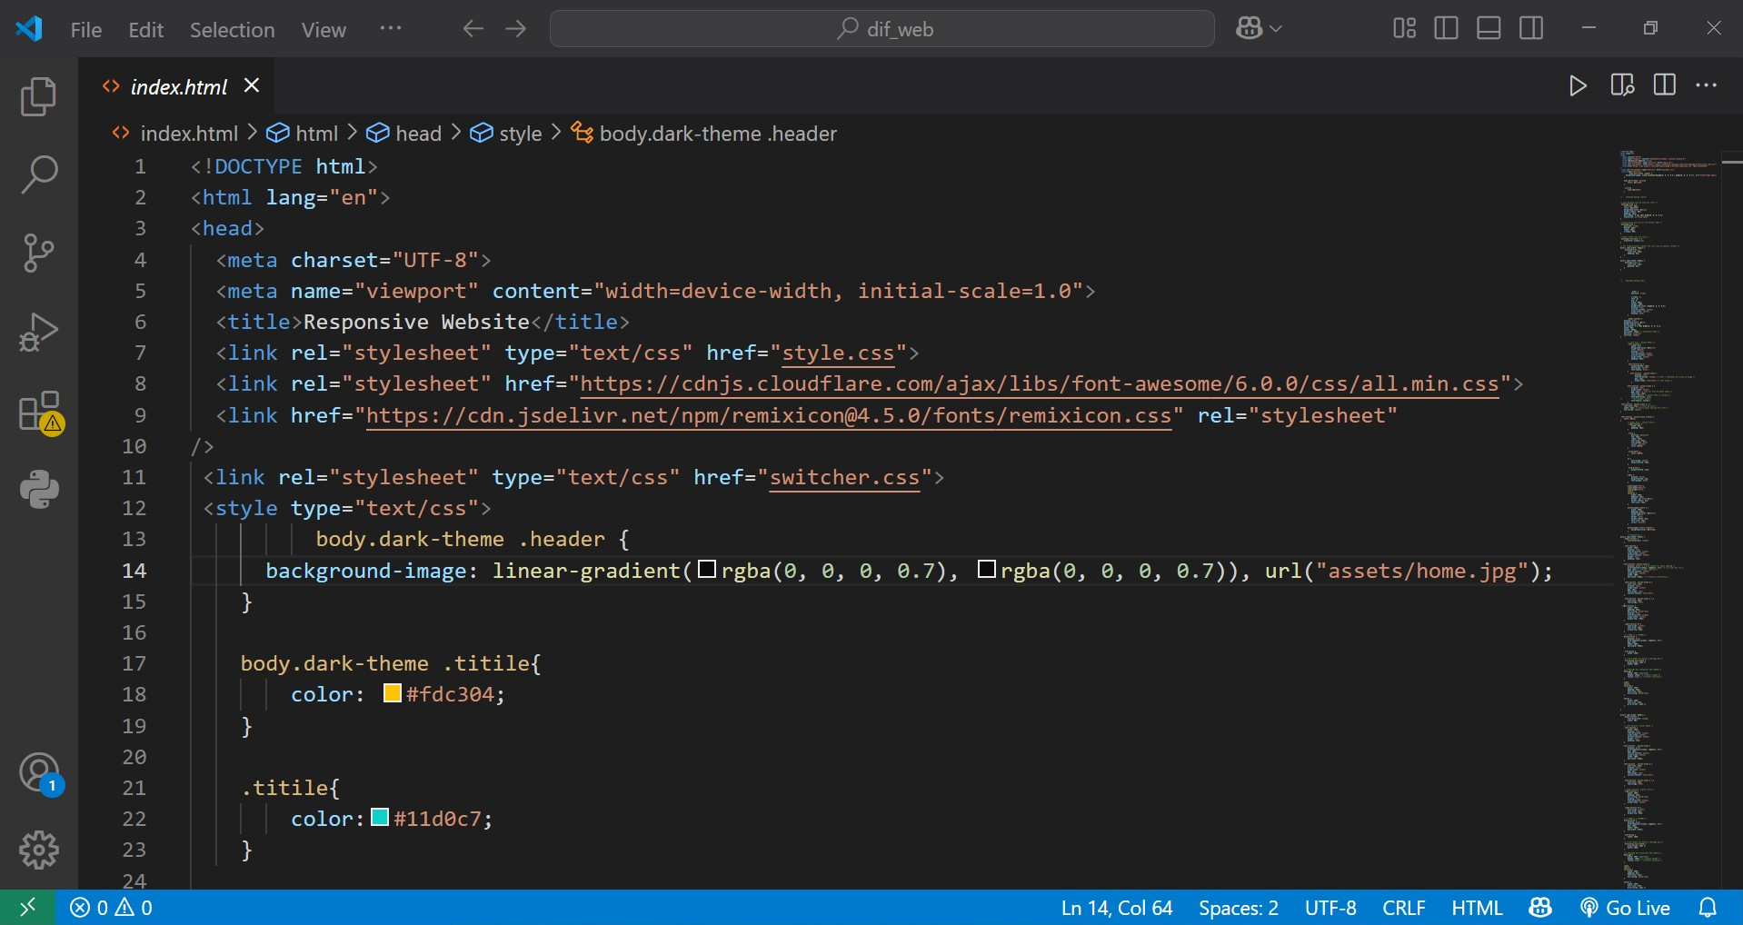

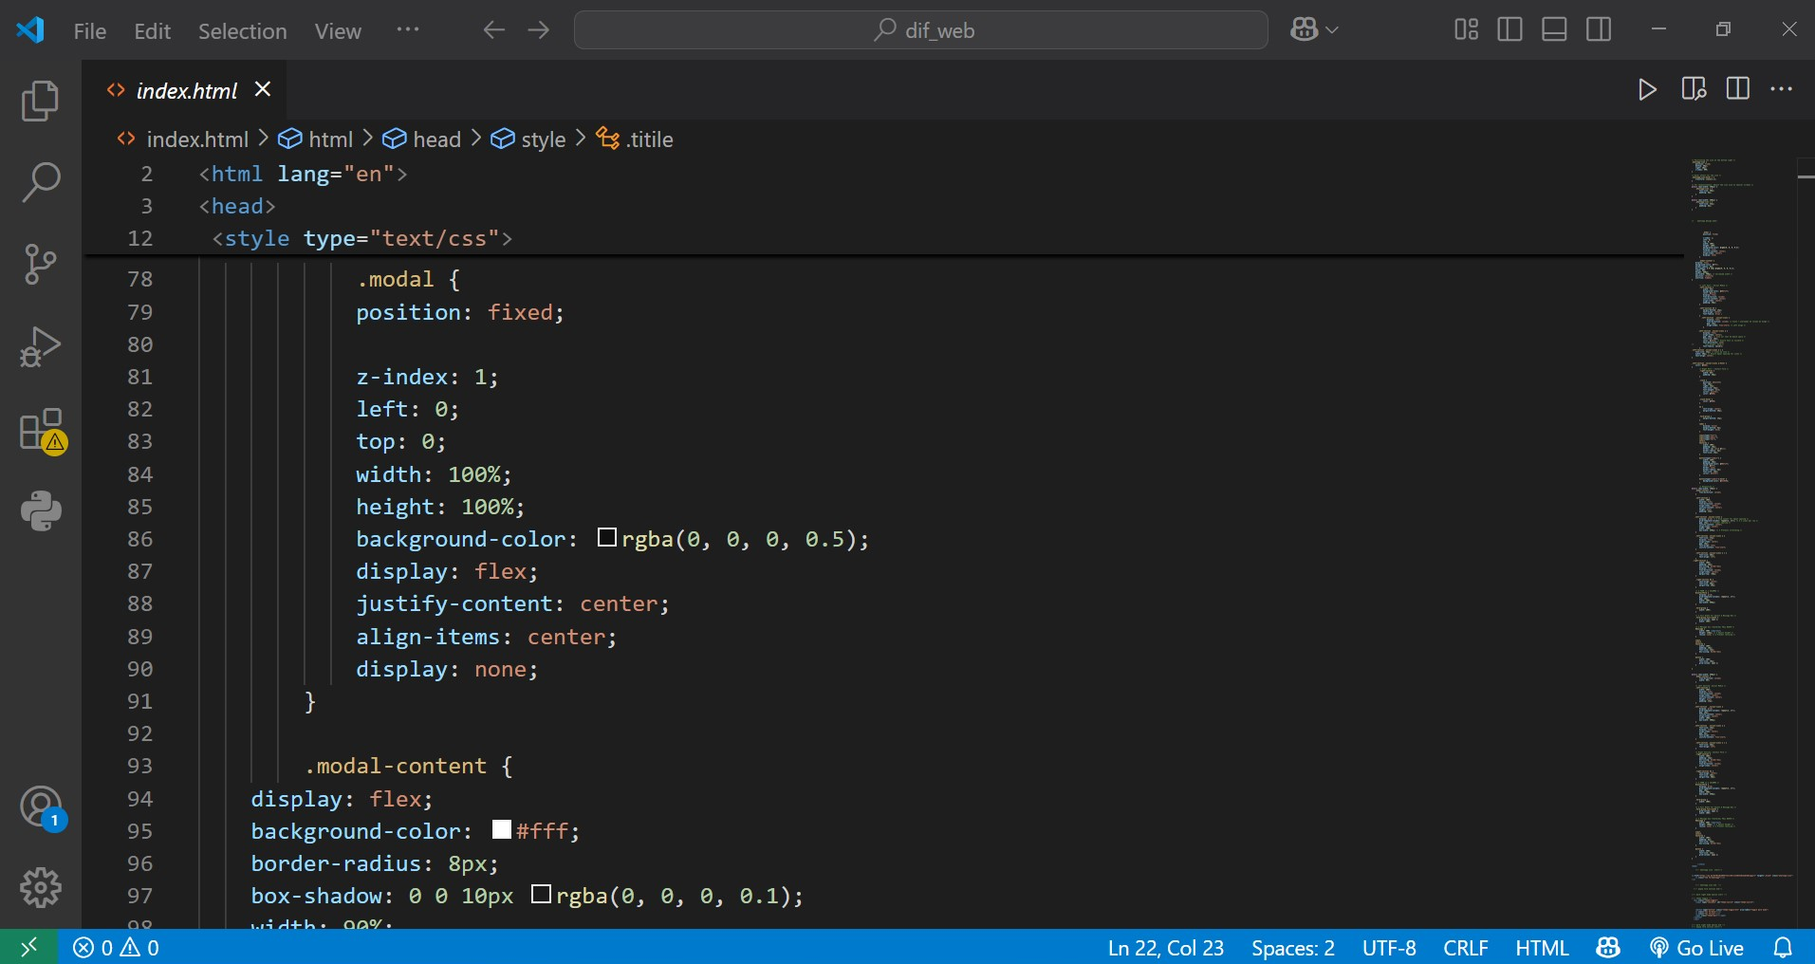

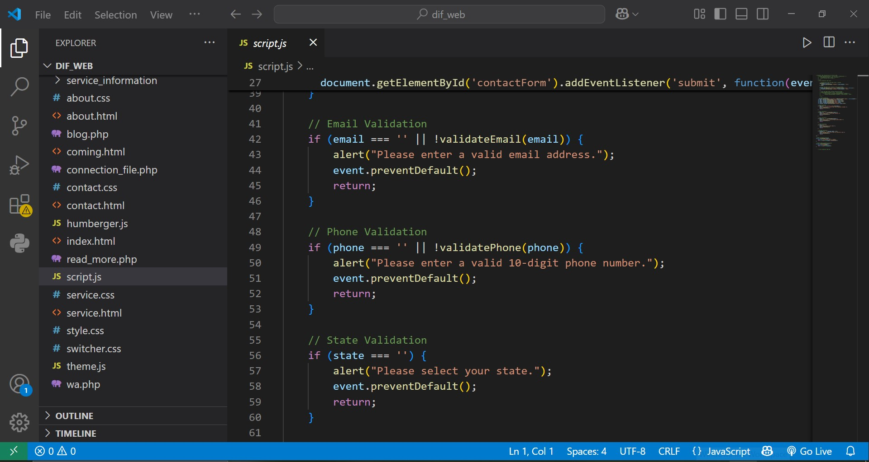

These are some of the code snippents .

11. RESULTS AND DISCUSSIONS

THE GUI:

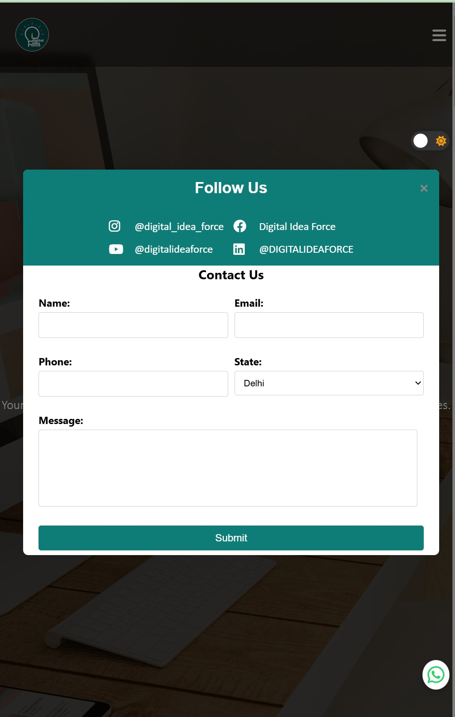



12.1. FUTURE WORK

In future we will be adding a crm software in their website and will be solving their problems . And also we will be adding a chat bot in their website so that even if someone having doubt or need some basic aswer the chat bot can answer them within time.

12.2. CONCLUSION
The development of the Digital Idea Force website marks a significant step in enhancing the agency’s digital presence and client engagement. By leveraging modern web technologies such as HTML, CSS, JavaScript, PHP, and MySQL, the project successfully delivered a fully responsive, SEO-optimized, and user-centric platform. The website not only showcases the agency's diverse range of services and expertise but also ensures an intuitive browsing experience through interactive features and streamlined navigation.
Through meticulous planning, design, development, and testing, the project achieved its primary objectives: establishing a strong online identity, improving discoverability through SEO, and enhancing user interaction via real-time contact forms and dynamic service pages. The website was implemented with performance and scalability in mind, ensuring it can adapt to evolving business needs and technological advancements.
The inclusion of analytics tools and user feedback mechanisms sets the stage for continuous improvement and data-driven decision-making. Looking forward, future enhancements will include the integration of a CRM system to streamline client management and a chatbot to provide instant support and information to visitors—further solidifying Digital Idea Force’s reputation as an innovative and customer-focused marketing agency.
This project stands as a robust foundation for Digital Idea Force’s continued growth in the competitive digital marketing industry, combining creativity, functionality, and performance to deliver real value to both the business and its clients.

13. REFERENCES
• Nielsen Norman Group. (2022). Usability Heuristics for User Interface Design. Retrieved from https://www.nngroup.com/articles/ten-usability-heuristics/
• Moz. (2023). The Beginner’s Guide to SEO. Retrieved from https://moz.com/beginners-guide-to-seo
• Google Developers. (2024). Web Fundamentals: Best Practices for Modern Web Development. Retrieved from https://developers.google.com/web/fundamentals/
• W3Schools. (2024). HTML, CSS, JavaScript, PHP, and MySQL Tutorials. Retrieved from https://www.w3schools.com/
• HubSpot. (2023). What is Marketing Automation?. Retrieved from https://blog.hubspot.com/marketing/marketing-automation-definition
• Statista. (2024). Number of Internet Users Worldwide. Retrieved from https://www.statista.com/statistics/273018/number-of-internet-users-worldwide/
• Smashing Magazine. (2023). Responsive Web Design: What It Is And How To Use It. Retrieved from https://www.smashingmagazine.com/2011/01/guidelines-for-responsive-web-design/
• Salesforce. (2023). Benefits of CRM Software. Retrieved from https://www.salesforce.com/products/what-is-crm/
• Search Engine Journal. (2023). Top SEO Trends To Watch. Retrieved from https://www.searchenginejournal.com/seo-trends/
• IBM. (2023). The Importance of User Experience (UX). Retrieved from https://www.ibm.com/design/thinking/page/framework

